Assessment: MS Fabric Assessment

Pavan Sivarathri

**Lakehouse Creation:**

**Loading Files:**

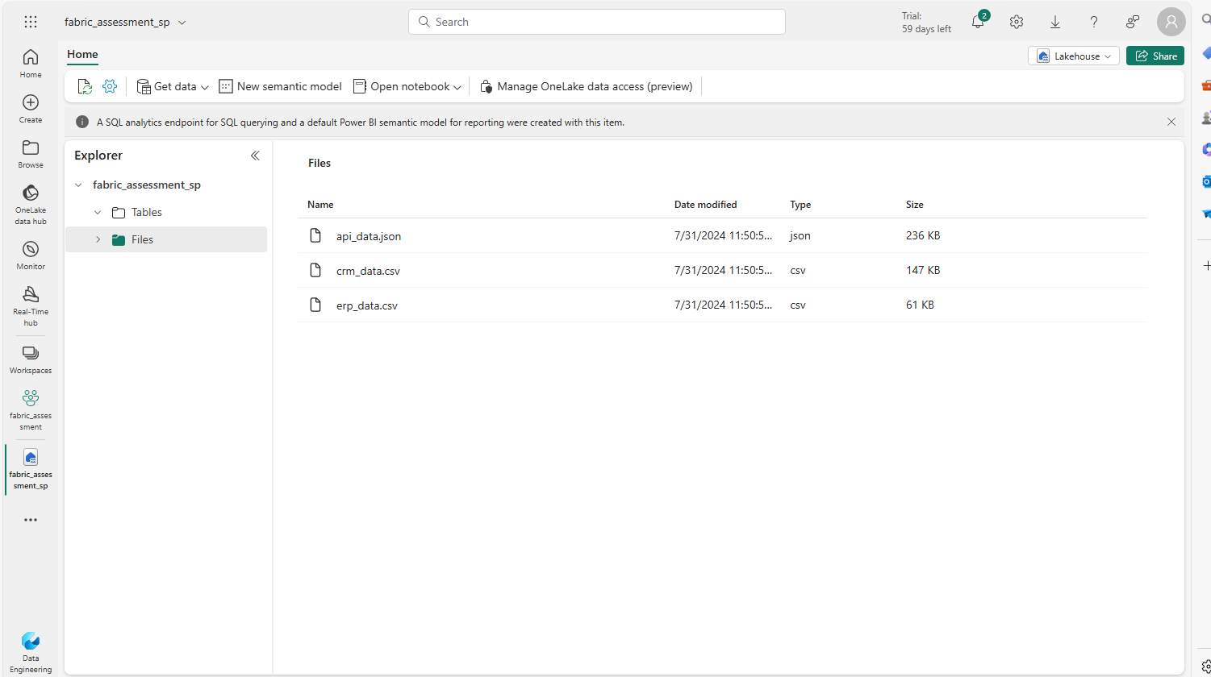

**Data Pipeline:**

